Professional Bios

Linda Gardner 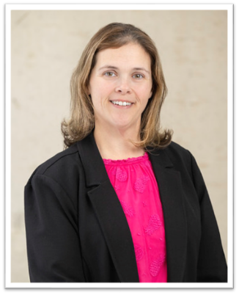
As Cleveland Clinic’s Senior Director of Nursing Education and Professional Development, Linda Gardner, DNP, MEd, BA, RN, CNOR, for a non-profit, multi-site community health care system and leads a team who ensures caregivers are prepared to work safely and effectively. Gardner brings seventeen years of nursing experience to her position having worked as a surgical technologist, circulator, clinical coordinator, educator, and manager. She is dedicated to the highest level of practice and shares her expertise to drive meaningful and impactful change. Gardner manages and oversees ambulatory, perioperative, hospice/homecare, care management, and reprocessing education. She is responsible for a 40-million-dollar donor-funded program and nursing pipeline programs under the Center for Nursing Career Exploration. In her prior role, as the Surgical Nursing Education Manager, she successfully developed Cleveland Clinic’s Reprocessing Education Team bridging educational gaps throughout the enterprise. She effectively built a perioperative education team that collaborates across all Cleveland Clinic locations creating and implementing evidence-based educational opportunities. To increase role clarity, Gardner implemented interactive learning in the department including simulations, games, skits, and competency circuits. She led the team to develop a perioperative immersion course with Ursuline College leading her team to two innovation awards: third place Innovation Award from Cleveland Clinic in 2020 and the Innovation Award from the Ohio League of Nursing in 2021. Gardner is a co-creator of the OR Nurse Associate Extern Program. She has presented several poster presentations ranging from Malignant Hyperthermia to Universal Protocol at AORN and ASPAN conferences. She presented a podium presentation "Schools in Session: Building an Academic/Clinical Partnership” at the 2021 AORN Global Surgical Conference and Expo. Gardner holds a Doctor of Nursing from Grand Canyon University, a master’s in nursing from the University of Phoenix, a Master of Education from Indiana Wesleyan University, and a bachelor of arts in mathematics from Ursuline College.
Theresa Russo 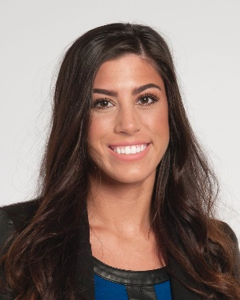
Theresa Russo is a Program Manager in the Office of Nursing Education and Professional Development at Cleveland Clinic. She has over 12 years of experience in project management, strategic operations, budget management, and marketing. Most recently in her role, she manages several key enterprise-wide nursing pipeline programs and supports budget and finance operations for the department. In her previous role as Program Manager in Protective Operations, she led development and implementation of the enterprise-wide non-employee onboarding program which standardized compliance and enhanced efficiency across Cleveland Clinic health system. Theresa earned her bachelor’s degree in business management and marketing from Kent State University in 2012.

